6-Lobaratoriya.PHP orqali CRUD (Create, Read, Update, Delete) amallarini bajarish

Ishdan maqsad
- PHP va MySQL yordamida ma’lumotlar bazasi bilan ishlashni o‘rganish
- CRUD (Create, Read, Update, Delete) amallarini amalda bajarish
- HTML forma orqali ma’lumotlarni kiritish va qayta ishlash
- Ma’lumotlar bazasidagi yozuvlarni chiqarish, tahrirlash va o‘chirish

Kerakli dasturiy vositalar
- XAMPP / OpenServer / Denwer
- PHP 7.x yoki yuqori
- MySQL
- Brauzer (Chrome, Edge va h.k.)
- Kod muharriri (VS Code, Sublime va boshqalar)

Nazariy qism
CRUD tushunchasi
CRUD – bu ma’lumotlar bazasida bajariladigan 4 asosiy amal:
Amal | Tavsif
Create | Yangi ma’lumot qo‘shish
Read | Ma’lumotlarni o‘qish (ko‘rish)
Update | Ma’lumotni tahrirlash
Delete | Ma’lumotni o‘chirish

1-qadam: Ma’lumotlar bazasini yaratish
phpMyAdmin orqali quyidagi SQL so‘rovni bajaring:
CREATE DATABASE talaba_db;
USE talaba_db;
CREATE TABLE talabalar (
id INT AUTO_INCREMENT PRIMARY KEY,
ism VARCHAR(50) NOT NULL,
familiya VARCHAR(50) NOT NULL,
yosh INT NOT NULL
);

2-qadam: Loyihaning fayl tuzilmasi
crud/
│
├── db.php
├── index.php
├── add.php
├── edit.php
├── delete.php

3-qadam: Ma’lumotlar bazasiga ulanish (db.php)
<?php
$conn = new mysqli("localhost", "root", "", "talaba_db");
if ($conn->connect_error) {
die("Ulanishda xatolik: " . $conn->connect_error);
}
?>

4-qadam: CREATE – Ma’lumot qo‘shish (add.php)
<?php
include 'db.php';
if(isset($_POST['submit'])){
$ism = $_POST['ism'];
$familiya = $_POST['familiya'];
$yosh = $_POST['yosh'];
$sql = "INSERT INTO talabalar (ism, familiya, yosh)
VALUES ('$ism', '$familiya', '$yosh')";
$conn->query($sql);
header("Location: index.php");
}
?>
<form method="POST">
Ism: <input type="text" name="ism"><br>
Familiya: <input type="text" name="familiya"><br>
Yosh: <input type="number" name="yosh"><br>
<button type="submit" name="submit">Saqlash</button>
</form>

5-qadam: READ – Ma’lumotlarni chiqarish (index.php)
<?php include 'db.php'; ?>
<a href="add.php">Yangi talaba qo‘shish</a>
<table border="1">
<tr>
<th>ID</th>
<th>Ism</th>
<th>Familiya</th>
<th>Yosh</th>
<th>Amallar</th>
</tr>
<?php
$result = $conn->query("SELECT * FROM talabalar");
while($row = $result->fetch_assoc()){
echo "<tr>
<td>{$row['id']}</td>
<td>{$row['ism']}</td>
<td>{$row['familiya']}</td>
<td>{$row['yosh']}</td>
<td>
<a href='edit.php?id={$row['id']}'>Tahrirlash</a>
<a href='delete.php?id={$row['id']}'>O‘chirish</a>
</td>
</tr>";
}
?>
</table>

6-qadam: UPDATE – Ma’lumotni tahrirlash (edit.php)
<?php
include 'db.php';
$id = $_GET['id'];
$result = $conn->query("SELECT * FROM talabalar WHERE id=$id");
$row = $result->fetch_assoc();
if(isset($_POST['update'])){
$ism = $_POST['ism'];
$familiya = $_POST['familiya'];
$yosh = $_POST['yosh'];
$conn->query("UPDATE talabalar
SET ism='$ism', familiya='$familiya', yosh='$yosh'
WHERE id=$id");
header("Location: index.php");
}
?>
<form method="POST">
Ism: <input type="text" name="ism" value="<?php echo $row['ism']; ?>"><br>
Familiya: <input type="text" name="familiya" value="<?php echo $row['familiya']; ?>"><br>
Yosh: <input type="number" name="yosh" value="<?php echo $row['yosh']; ?>"><br>
<button type="submit" name="update">Yangilash</button>
</form>

7-qadam: DELETE – Ma’lumotni o‘chirish (delete.php)
<?php
include 'db.php';
$id = $_GET['id'];
$conn->query("DELETE FROM talabalar WHERE id=$id");
header("Location: index.php");
?>

Topshiriqlar:
19.TOPSHIRIQ: “Logistika Transport”
Database: logistics_transport_db
Jadval: cargo_transfers
Ustunlar:
- transfer_id
- shipment_label
- origin_point
- destination_point
- dispatch_datetime
- delivery_datetime
- carrier_agent
- shipment_condition

CREATE DATABASE logistics_transport_db;
USE logistics_transport_db;
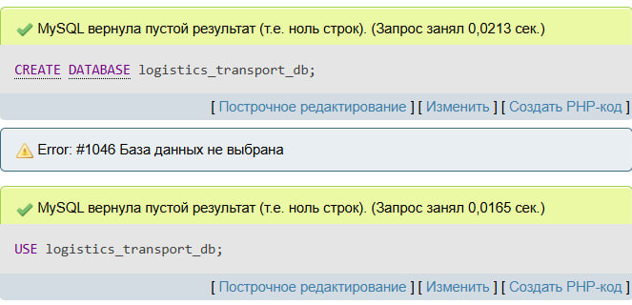
CREATE TABLE cargo_transfers (
transfer_id INT AUTO_INCREMENT PRIMARY KEY,
shipment_label VARCHAR(100),
origin_point VARCHAR(100),
destination_point VARCHAR(100),
dispatch_datetime DATETIME,
delivery_datetime DATETIME,
carrier_agent VARCHAR(100),
shipment_condition VARCHAR(50)
);
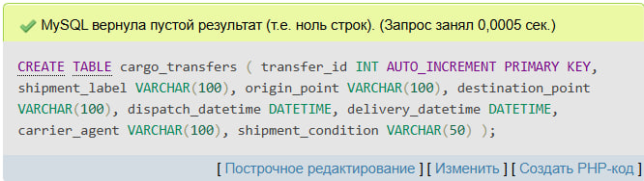

Index.php
<?php
$conn = new mysqli("localhost","root","","logistics_transport_db");

if ($conn->connect_error) {
die("Ulanishda xatolik!");
}

if(isset($_POST['add_transfer'])){

$shipment_label = $_POST['shipment_label'];
$origin_point = $_POST['origin_point'];
$destination_point = $_POST['destination_point'];
$dispatch_datetime = $_POST['dispatch_datetime'];
$delivery_datetime = $_POST['delivery_datetime'];
$carrier_agent = $_POST['carrier_agent'];
$shipment_condition = $_POST['shipment_condition'];

$conn->query("INSERT INTO cargo_transfers
(shipment_label,origin_point,destination_point,dispatch_datetime,delivery_datetime,carrier_agent,shipment_condition)

VALUES
('$shipment_label','$origin_point','$destination_point','$dispatch_datetime','$delivery_datetime','$carrier_agent','$shipment_condition')");
}

$result = $conn->query("SELECT * FROM cargo_transfers");
?>

<!DOCTYPE html>
<html>
<head>
<title>Logistika Transport</title>

<style>

body{
font-family: Arial;
padding:40px;
background:#f4f4f4;
}

form{
background:white;
padding:15px;
margin-bottom:20px;
}

input{
padding:8px;
margin:5px;
}

table{
width:100%;
border-collapse: collapse;
background:white;
}

th,td{
border:1px solid #ccc;
padding:10px;
text-align:center;
}

th{
background:#667eea;
color:white;
}

.filter input{
width:90%;
}

</style>

</head>
<body>

<h2>Yuk tashish qo‘shish</h2>

<form method="POST">

<input type="text" name="shipment_label" placeholder="Yuk nomi" required>

<input type="text" name="origin_point" placeholder="Jo‘natilgan joy" required>

<input type="text" name="destination_point" placeholder="Yetkaziladigan joy" required>

<input type="datetime-local" name="dispatch_datetime" required>

<input type="datetime-local" name="delivery_datetime" required>

<input type="text" name="carrier_agent" placeholder="Transport agenti" required>

<input type="text" name="shipment_condition" placeholder="Yuk holati" required>

<button name="add_transfer">Qo‘shish</button>

</form>

<h2>Yuk tashish ro‘yxati</h2>

<table>

<tr>
<th>ID</th>
<th>Yuk nomi</th>
<th>Qayerdan</th>
<th>Qayerga</th>
<th>Jo‘natilgan vaqt</th>
<th>Yetkazilgan vaqt</th>
<th>Agent</th>
<th>Holati</th>
</tr>

<!-- INPUT QATORI -->

<tr class="filter">

<td><input type="text" placeholder="ID"></td>

<td><input type="text" placeholder="Yuk nomi"></td>

<td><input type="text" placeholder="Qayerdan"></td>

<td><input type="text" placeholder="Qayerga"></td>

<td><input type="text" placeholder="Jo‘natilgan vaqt"></td>

<td><input type="text" placeholder="Yetkazilgan vaqt"></td>

<td><input type="text" placeholder="Agent"></td>

<td><input type="text" placeholder="Holati"></td>

</tr>

<?php while($row = $result->fetch_assoc()) { ?>

<tr>

<td><?= $row['transfer_id'] ?></td>

<td><?= $row['shipment_label'] ?></td>

<td><?= $row['origin_point'] ?></td>

<td><?= $row['destination_point'] ?></td>

<td><?= $row['dispatch_datetime'] ?></td>

<td><?= $row['delivery_datetime'] ?></td>

<td><?= $row['carrier_agent'] ?></td>

<td><?= $row['shipment_condition'] ?></td>

</tr>

<?php } ?>

</table>

</body>
</html>

